You are about to write an application that simulates a client-server architecture of a high performance and highly scalable “**Dashboard**” product.

http://icons.iconarchive.com/icons/martz90/hex/128/browser-icon.png

**Clients:**

The clients will be created as Angular 8+ app and can be run from any device on any browser.

* Each “client” **generates** (and updates the “server”) with an IP address, client type and OS version.
* As long as the client is running, the server will be aware of his online mode (grace period of few seconds is acceptable).
* You are required to simulate at least 5 clients.
* Simple UI that shows the full list of clients and their online status. If a client was terminated then it will be indicated using an offline mode status/icon.
* **Bonus** – usage of State Management and/or material design.
* Example for client status:

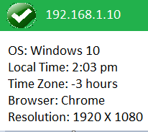

http://icons.iconarchive.com/icons/oxygen-icons.org/oxygen/128/Places-server-database-icon.png

**Server:**

The server should manage clients’ data and their real-time connection status (online/offline). Use the console to output communication and process inspection results.

Server should be written in .NET Core or Java.

You need to provide a script/document that orchestrates and runs the entire system.